To connect CD-ROM to your virtual machine

- Under Role Console tab, click on the drop down to select the CD-ROM ISO,
rhel-server-6.4-x86_64-dvd, for your virtual Machine.
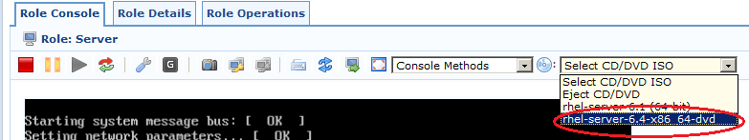

- Mount the device from the terminal window using the following command,
mount /dev/xvdd /media/dvd, using root account with root password as redhat as shown below.
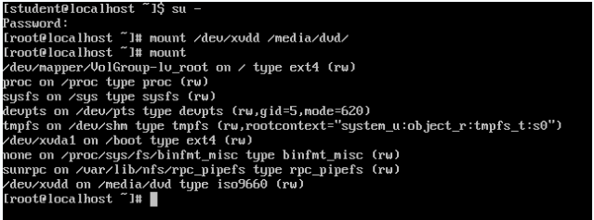

- When the operation is completed, you will be able to access your ISO through console or VncViewer
